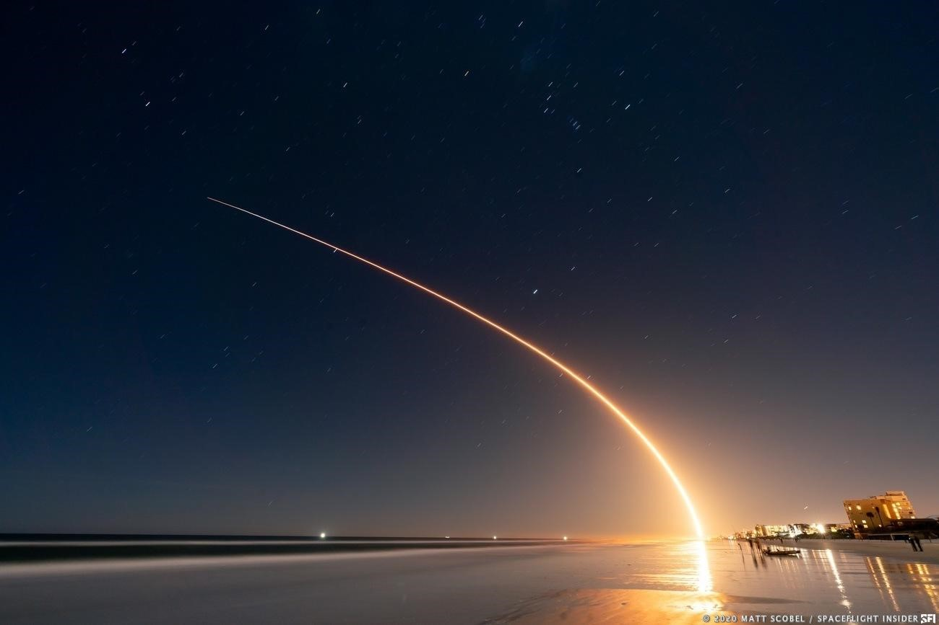

**Kevin KIHIKA**

**Aug 9th**

**, 2024**



**Winning Space Race**

**with Data Science**

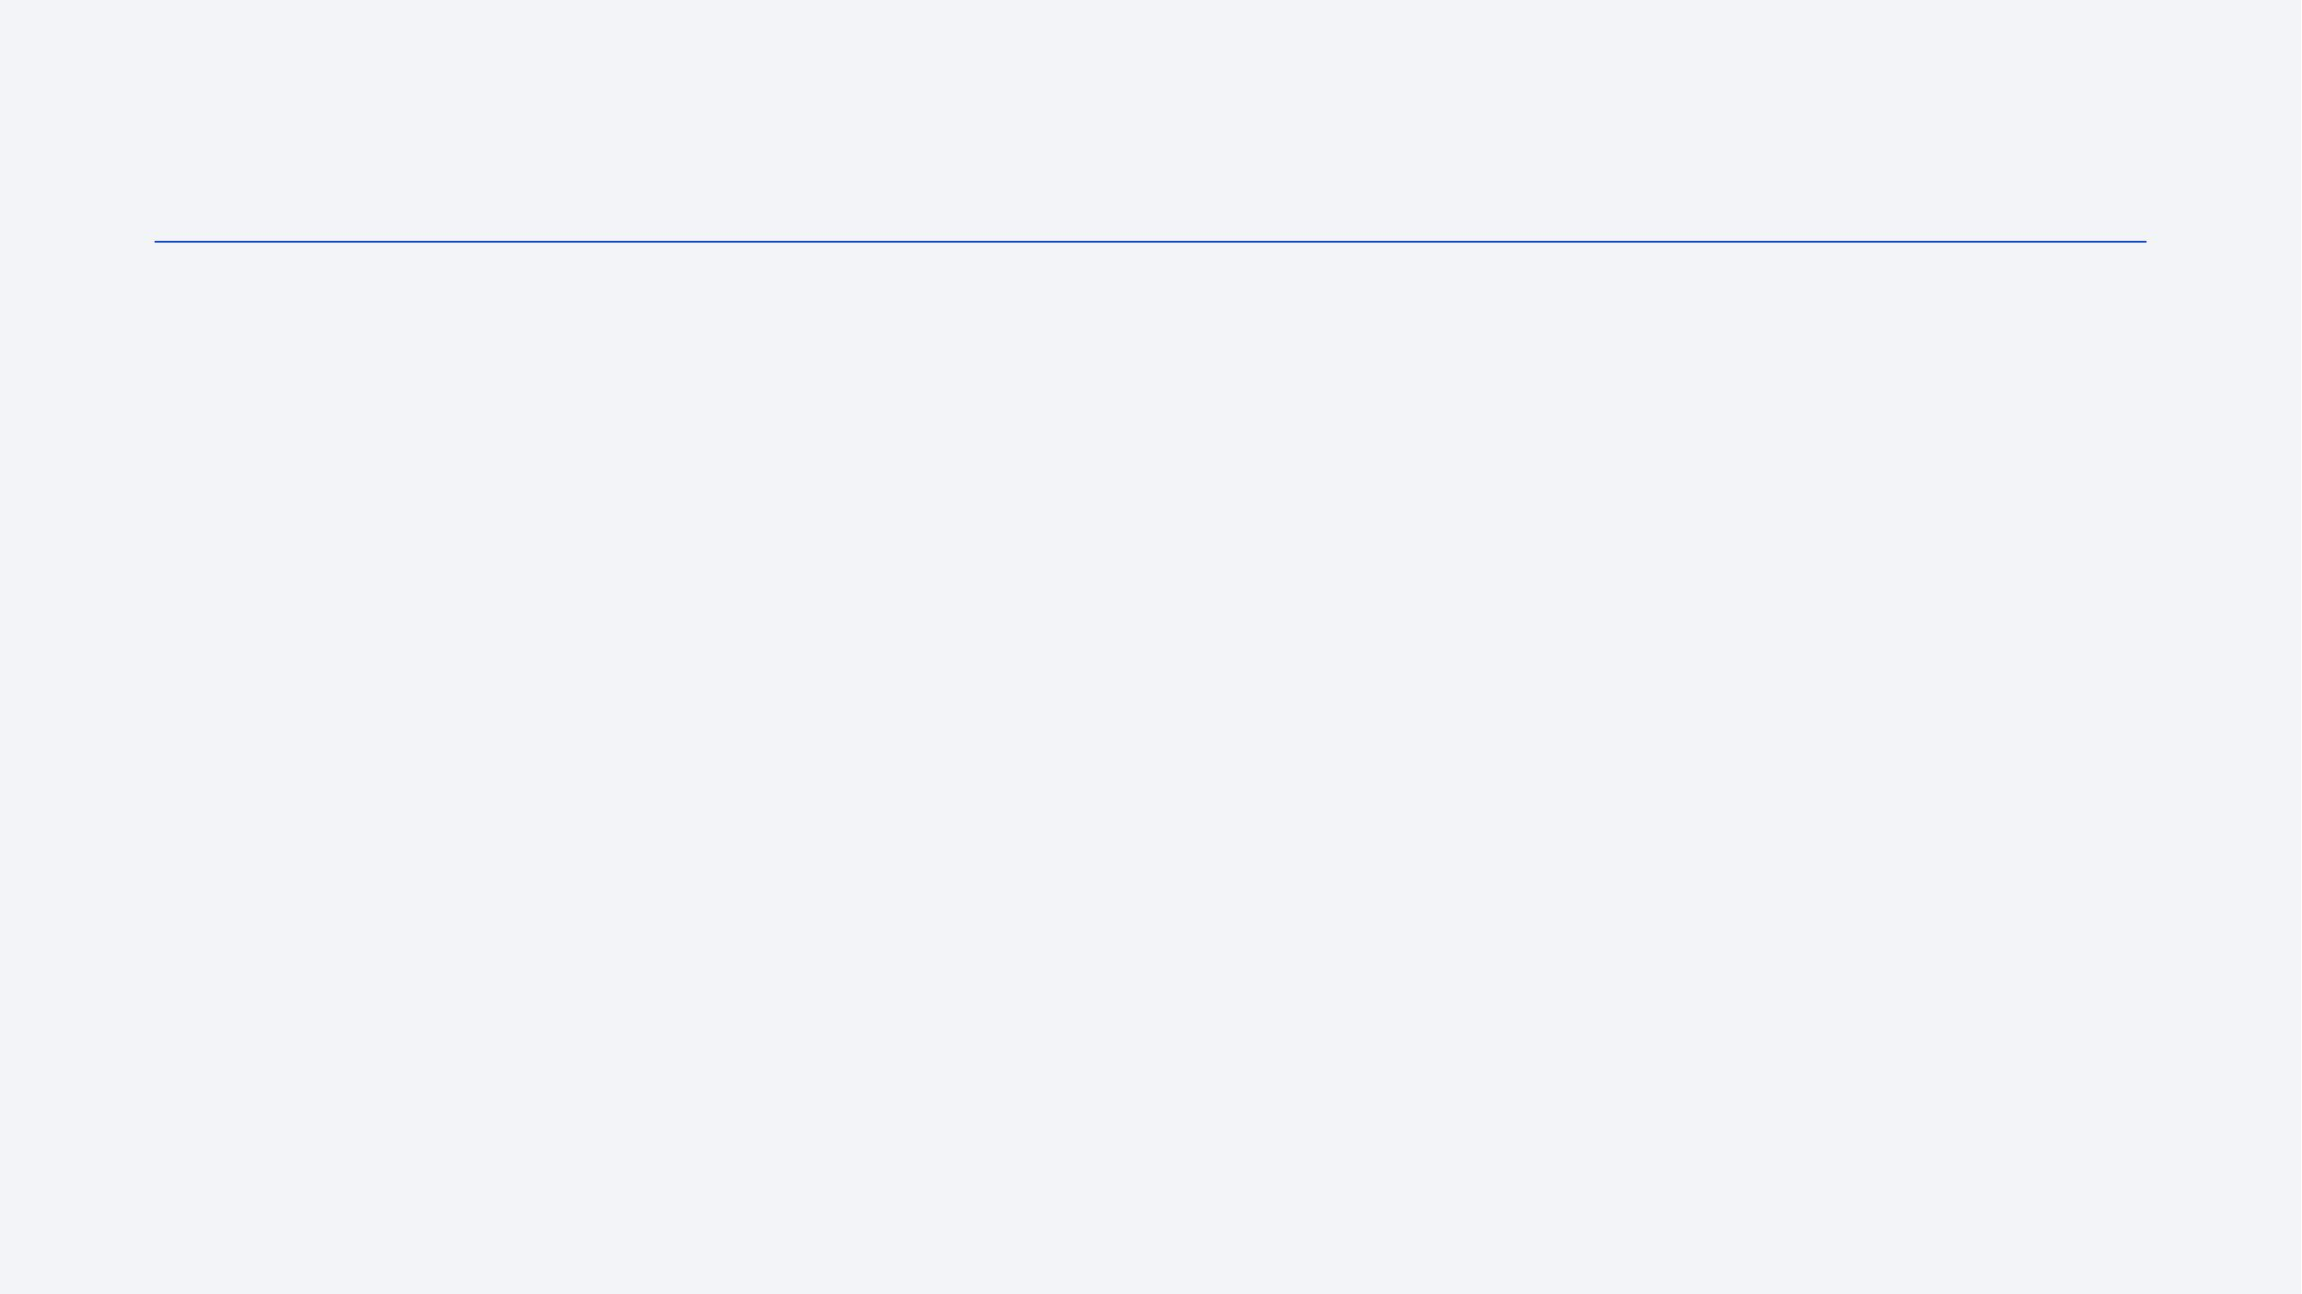

•

Executive Summary

•

Introduction

•

Methodology

•

Results

•

Conclusions

•

Appendix

Outline



Executive Summary

In a highly competitive business environment:

●

SpaceX has revolutionized the launch of satellites with a concept of reusable launcher/booster:

Falcon9/Falcon 9 Heavy

●

The main advantage of this concept is the significant reduction in cost per kg.

●

Reliability problems remain compared to classic launch vehicles like Soyuz or Ariane-5.

●

For maintaining the “low cost” competitive advantage, compared with classic launchers, Falcon9

mission success is defined as the successful recovery or landing of the booster.

●

Falcon9 booster successful recovery depends on features such as:

●

orbit

●

payload mass

●

booster versions

●

Launching sites…

●

Based on these features, the best Machine Learning supervised classification model developed in this

report, predicted booster recovery outcome with an accuracy close to 94%.



Introduction

●

Commercial rocket launches is a very competitive market.

●

From 2000 to 2017, Ariane 5 (ESA - Arianespace) dominated the market with: lower cost, high payload mass,

**reliability**

.

●

In terms of cost, China, India, Russia are tough competitors with less reliable classic launchers like LongMarch, Proton,

Soyuz-2, PSLV. New players like BlueHorizon are still in early stage.

●

Since 2017, SpaceX Falcon9/ Falcon9 Heavt is increasingly dominating the market with better cost per kg thanks to the

reusable booster concept.

●

Competition may heat up again with the advent of Ariane 6 and SpaceX Starship.

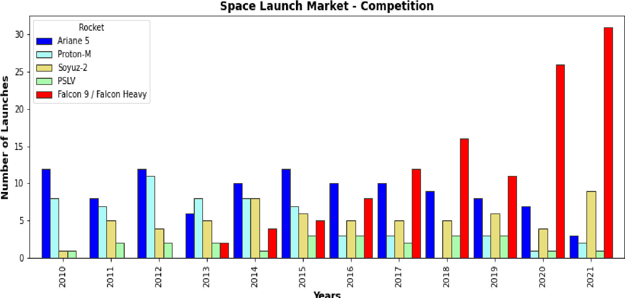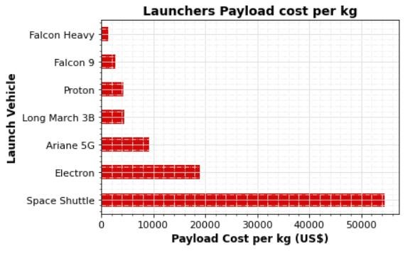

Introduction

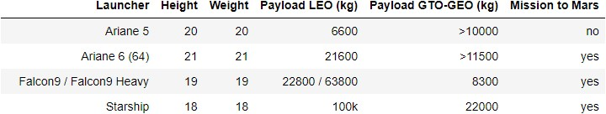

●

**Falcon 9/Falcon9 heavy v. Ariane 6**

●

Falcon9 / Falcon 9 Heavy can easily compete with new

Ariane 6 (2 or 4 boosters) in terms of:

●

Cost per kg

●

Payload mass

●

SpaceX Starship will further crush the competition in both

domains.

●

Falcon9 and Starship costs are way lower due to reuse of

boosters

●

Ariane-6 will be a classic launcher for reliability purposes

●

Falcon9 reliability can’t compete with Ariane-5G record

●

**Falcon9 booster recovery success rate is still an issue.**

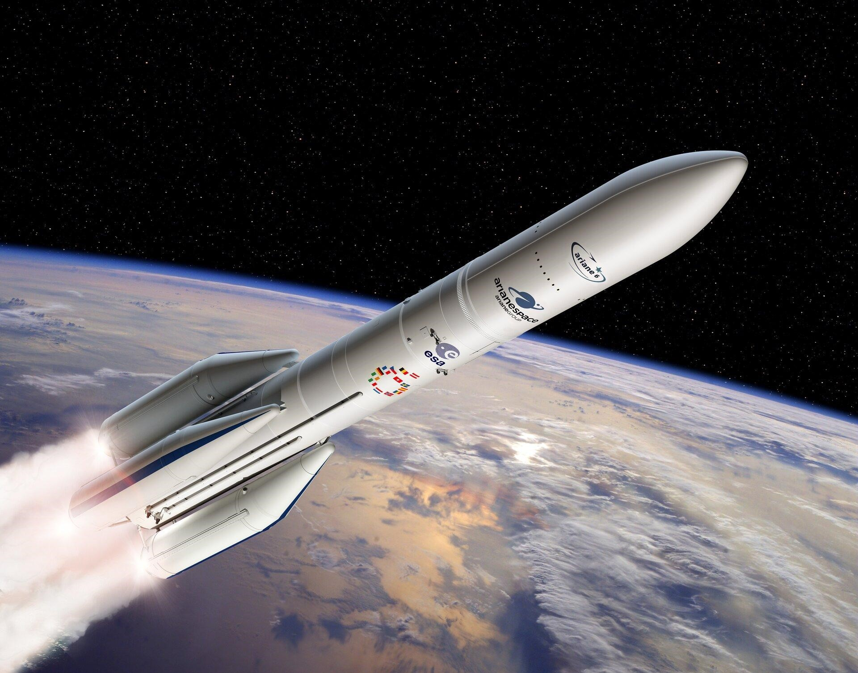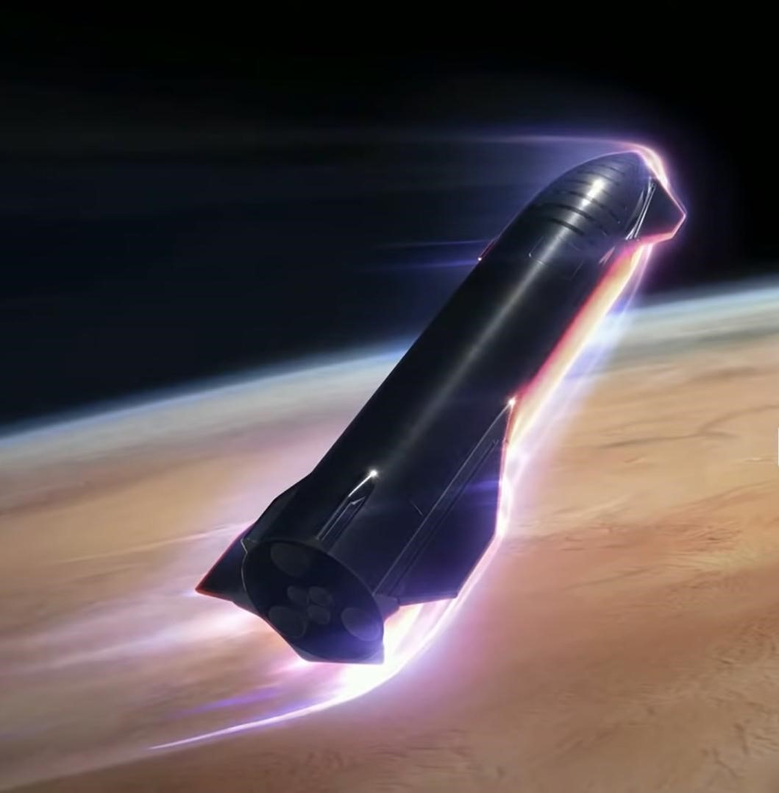

Ariane 64 (4 boosters) SpaceX Starship



Introduction

SpaceX CEO Elon Musk has criticized European efforts in the emergent new space

race. In March 2021, he wrote on Twitter:

*“*

*They are aiming too low. Only rockets that are fully & rapidly reusable will be*

*competitive. Everything else will seem like a cloth biplane in the age of jets.”*

●

Reliability v. Risky concept: “reusability” and Significant cost

reduction

●

SpaceX financial viability heavily depends on the successful landing

of the booster (booster recovery) defined as “mission success”.

●

Using SpaceX Falcon9 database, we develop AI tools:

➢

for visualizing, analyzing features conditioning mission success

➢

for predicting Falcon 9 success and SpaceX financial viability

using supervised classification algorithms.

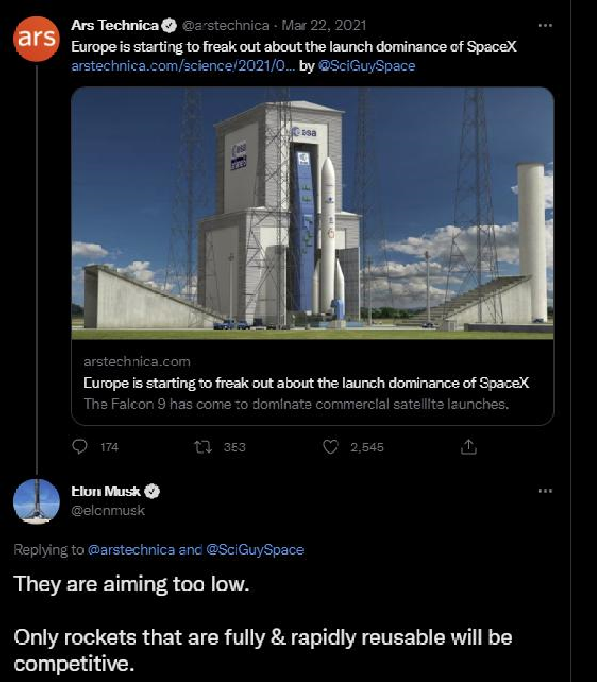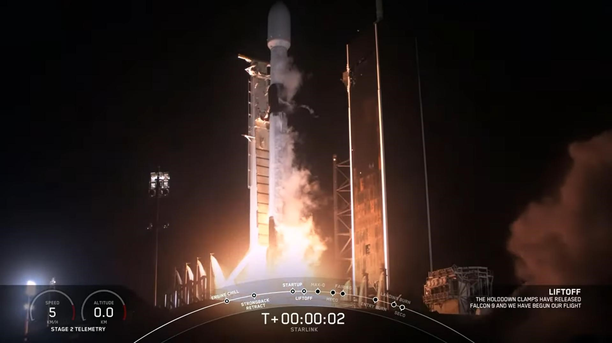

**8**

Section 1

**Methodology**



Methodology

**Methodology steps:**

**1**

**.**

**Data collection from open Data base and Wikipedia (Falcon9, Ariane-5).**

**2.**

**Data wrangling.**

**3.**

**Exploratory data analysis using SQL query and visualization of correlation between**

**parameters.**

**4.**

**Visual analytics: launch sites with Folium, success rates with Plotly Dash.**

**5.**

**Classification Models development and validations. Selection of best predictive model.**



Data Collection

Data was collected from:

open source SpaceX REST API

-

-

webscraping Falcon9 launch data in Wikipedia

webscraping Ariane5 launcher data in Wikipedia

-

***for***

***reference graphs only.***

(not prepared for ML)

Saved data into csv file

*data_set_part1.csv*

**Web scraping Wikipedia**

Clean

Extract Table data

with Beautiful soup

Get URL response

Saved data into csv file

*data_set_part2.csv*

**SpaceX REST API**

Replaced missing

payload value with

mean value

Restricted dataframe

to Falcon 9 launches

Requested and parsed

SpaceX launch data



Data Collection - Scraping

**Saved in a Dictionary**

**Appended Data to Keys**

**Acquired historical launch data from Wikipedia**

**page 'List of Falcon 9 and Falcon Heavy Launches'**

**Requested the Falcon9 Launch Wiki page from its**

**Wikipedia URL**

**Created a beautiful soup object**

**Converted Dictionary to**

**Dataframe**

**Saved Dataframe into**

**.csv file**

**Found all tables.**

**Extracted all column/variable**

**names from the HTML table**

**header**



Data Collection – SpaceX API

**Preliminary Stage**

**We defined a series of functions helping**

**the use the API to extract info using**

**identification numbers (IDs) in the launch**

**data.**

●

**getBoosterVersion(data)**

●

**getLaunchSite(data)**

●

**getPayloadData(data)**

●

**getCoreData(data)**

**Assigned list to dictionary**

**Converted to Dataframe**

**Requested rocket launch data from SpaceX API**

**Requested and parsed**

**SpaceX data with GET request**

**Decoded response as a .json file**

**Turned it into Pandas dataframe**

**Selected Falcon9 data only**

**Replaced missing payload mass**

**value with mean**

**Saved Dataframe into**

**.csv file**

**Used the API with functions to get**

**info from IDs:**

●

**BoosterVersion**

●

**Payloads**

●

**LaunchSite**

●

**Cores**

**Stored in List**



Data Wrangling

Created a set of 1

st

stage booster landing outcomes

True ASDS: successful landing on a drone ship

0

None None: failure to land

1

True RTLS: successful landing to a ground pad

2

3

False ASDS:

failed landing on a drone ship

True Ocean: successful landing, specific region of the ocean

4

5

False Ocean: failed landing, specific region of the ocean

6

None ASDS: failure to land

7

False RTLS: failed landing to a ground pad

Created a Training label: 'Class'

**Class = 0: booster landing failure**

**Class = 1: booster landing success**

Dataframe

From SpaceX API

Identified:

●

null values for each

feature

●

numerical and categorical

features

SpaceX dataset

Further Data wrangling

Identified missing values

Replaced missing “PayloadMass”

value with mean value

Calculated:

●

Number of launches on each site

●

number and occurrence of each orbit

●

number and occurrence of missions

outcome per orbit type

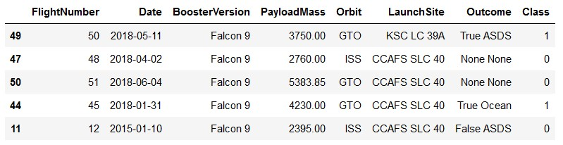

EDA with SQL

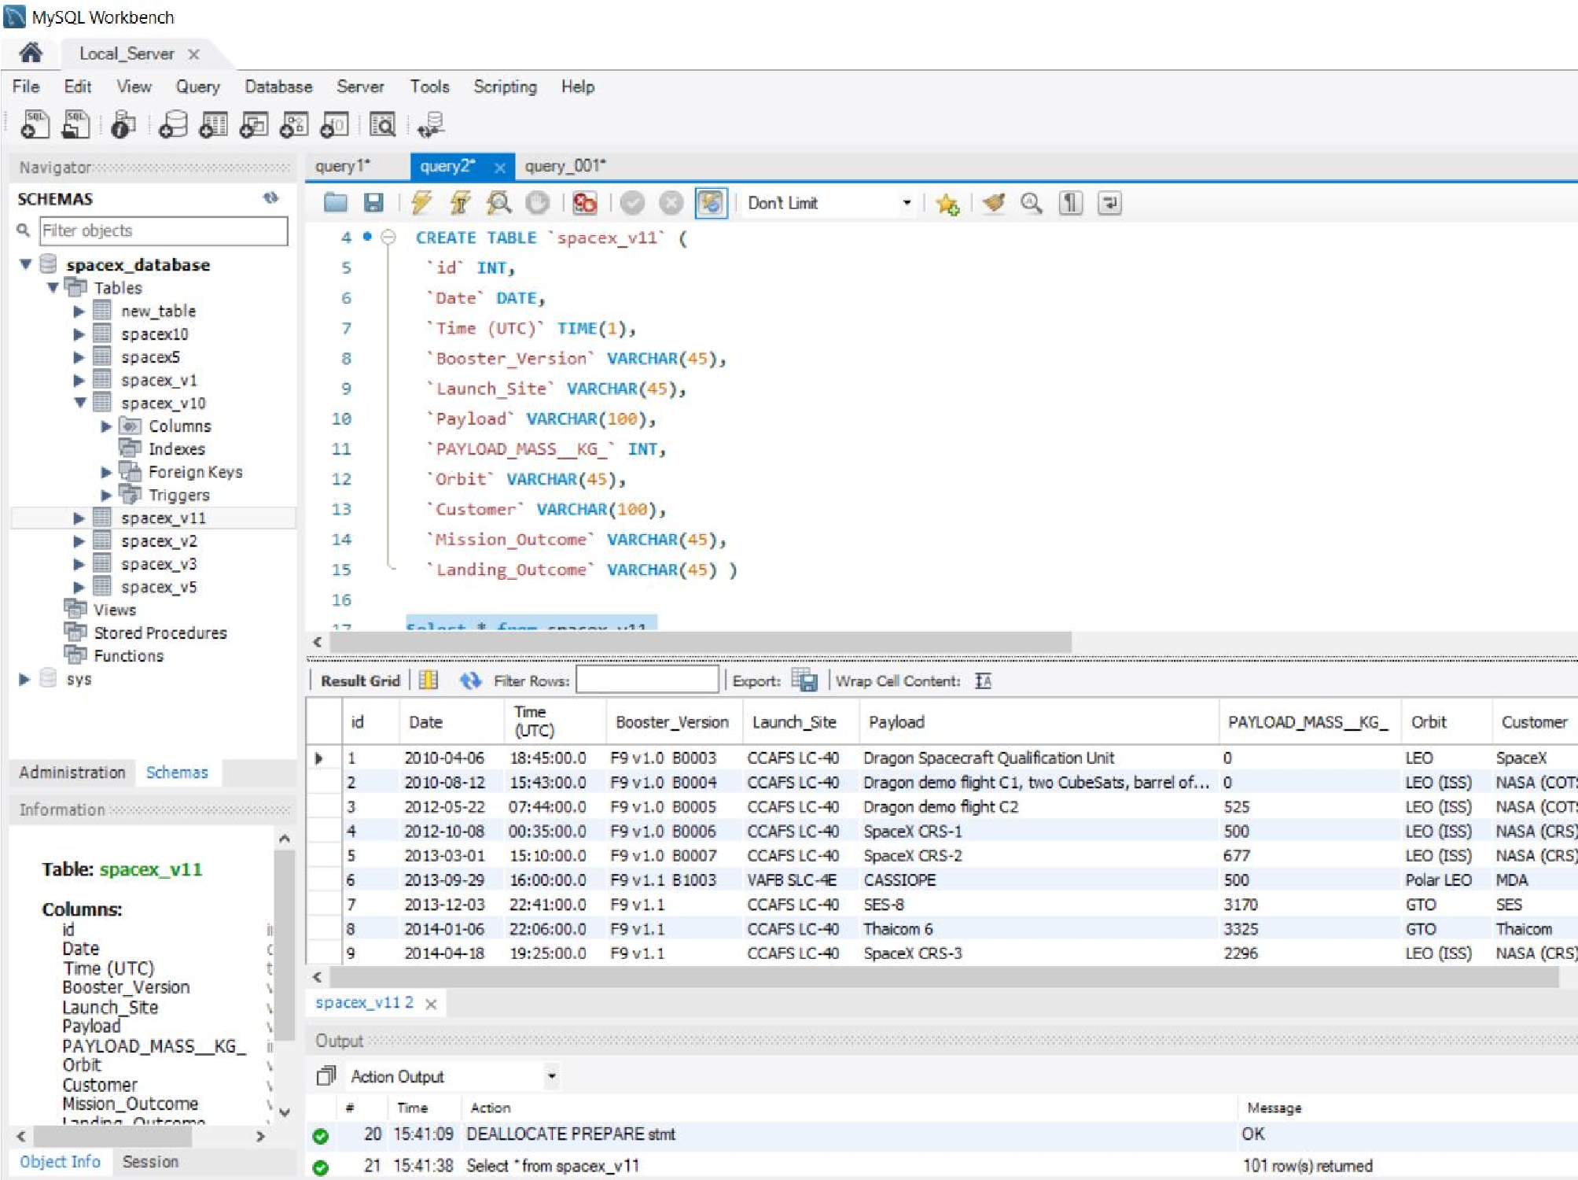

**MySQL local server**

Building “spacex_v11” table.

**For the reviewer,**

**for emulating SQL queries:**

●

**I created a MySQL local server**

●

**I created a database: 'spacex_database'**

●

**I saved SpaceX csv file in Table “spacex_v11” (see picture)**

●

**I established a connection “conn” wih “spacex_database”.**

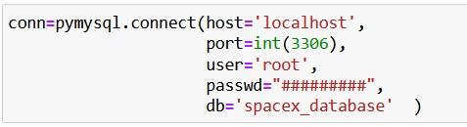

We ran SQL queries with “pd.read_sql_queries”:

1.

to download data in a Jupyter Notebook (dataframe)

2.

to display information about:

•

Launch sites

•

Payload mass

•

Booster versions

•

Mission outcomes

•

Booster landings

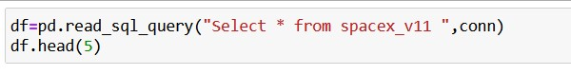

EDA with Data Visualization

Exploring data in the Falcon 9 dataframe searching for factors and

relations influencing launching success rate (booster recovery).

●

Payload mass

●

Orbit type

●

Launch site

Graphs and scatter charts with Matplotlib – Seaborn and Analysis.

Results with Scatter charts are labeled: class 0-1 (failure/success).

●

Payload mass v. Flight Number

●

Launch Site v. Flight number

●

Launch Site v. Payload mass

●

Orbit v. Flight number

●

Orbit v. Payload mass

●

Histogram: success rate for each orbit

●

Falcon 9 & Ariane-5 launch success yearly trend.

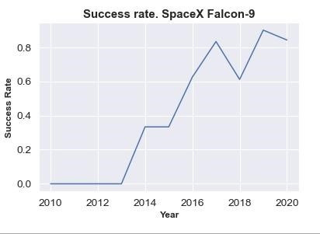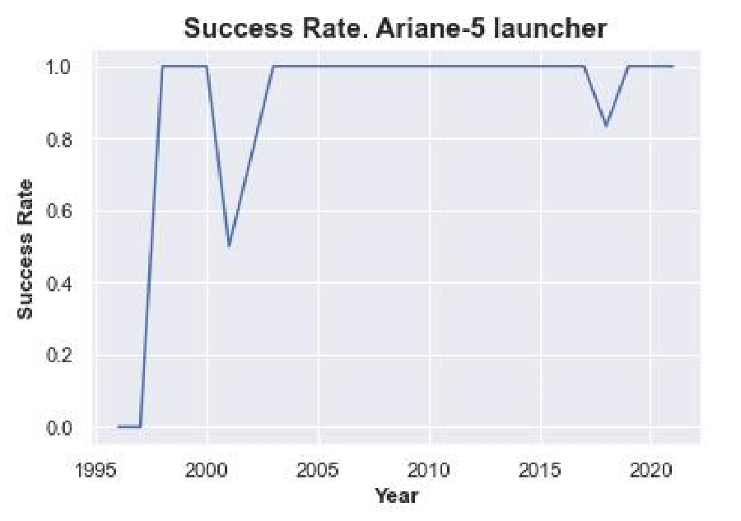

Build an Interactive Map with Folium

Launch success rate may depend on the location and proximity of a

launch site.

**Folium Interactive Map was used for visualizing and**

**analyzing SpaceX**

**Launch Sites.**

●

Used Interactive mapping library called Folium

●

Identified all SpaceX launch sites on a map: Florida, California

●

Included longitude and latitude info.

●

Identified successful/failed launches for each site on map

Calculated the distance between a launch site (CCAFS_SLC40 in Cape

Canaveral, FL ) and:

●

Closest coastline

●

Closest high traffic density railway: Florida East Coast Railway

●

Closest high traffic density highway: Interstate I95

●

Closest high density urban area: Orlando (FL)

For reference, we added the localization of European Space Agency

(

ESA) /ArianeEspace Ariane 5 and Soyuz launch pads in Kourou,

French Guiana

**.**

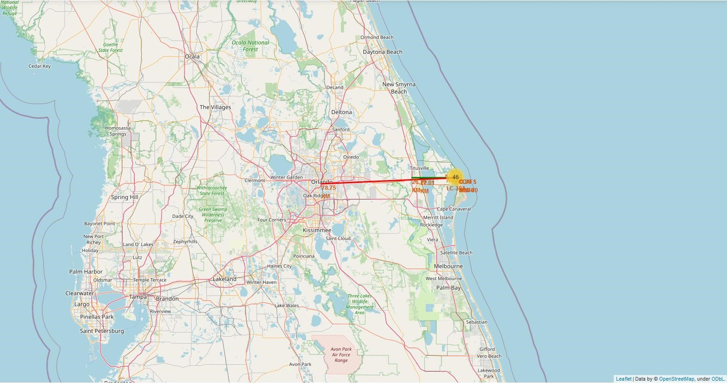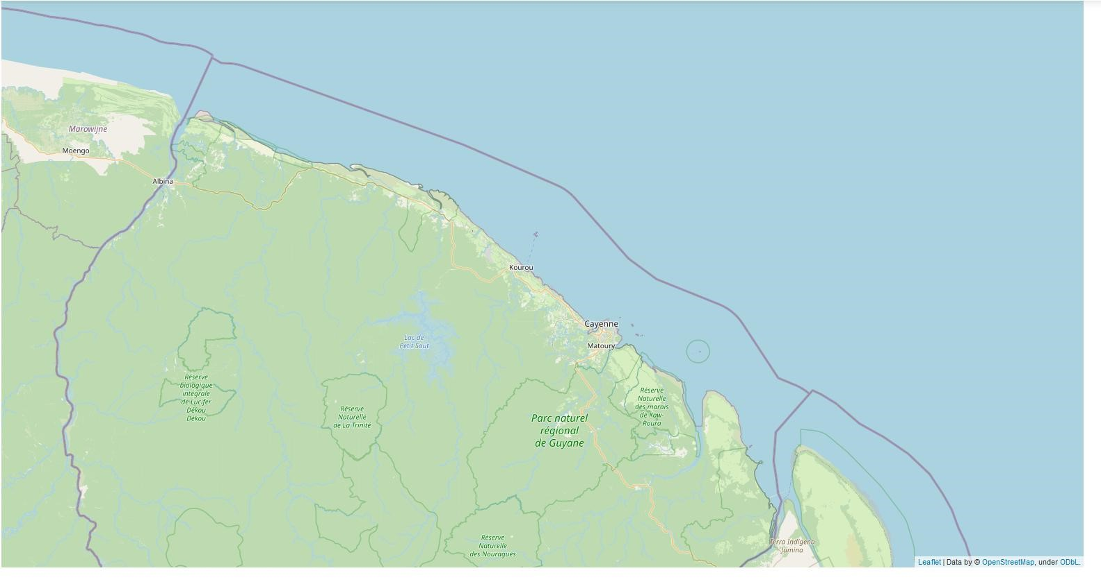

CCAFS_SLC40 in Cape Canaveral FL

Coordinates: -80.577

o

, 28.563

o

Ariane launch pad - Kourou in French Guiana

Coordinates: -52.792

o

,

**5.265**

**o**

**(**

**~ Equator**

**)**



Build a Dashboard with Plotly Dash

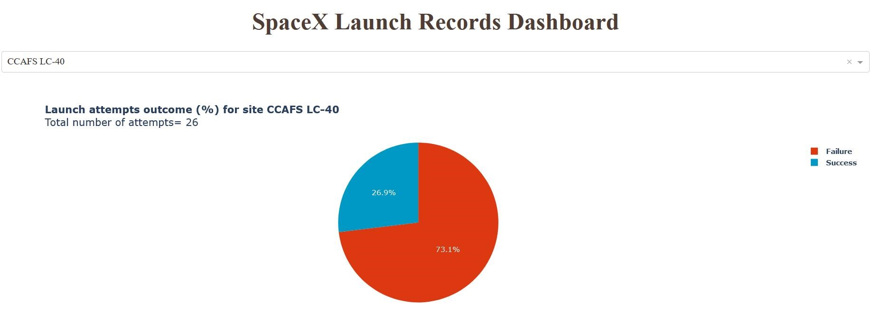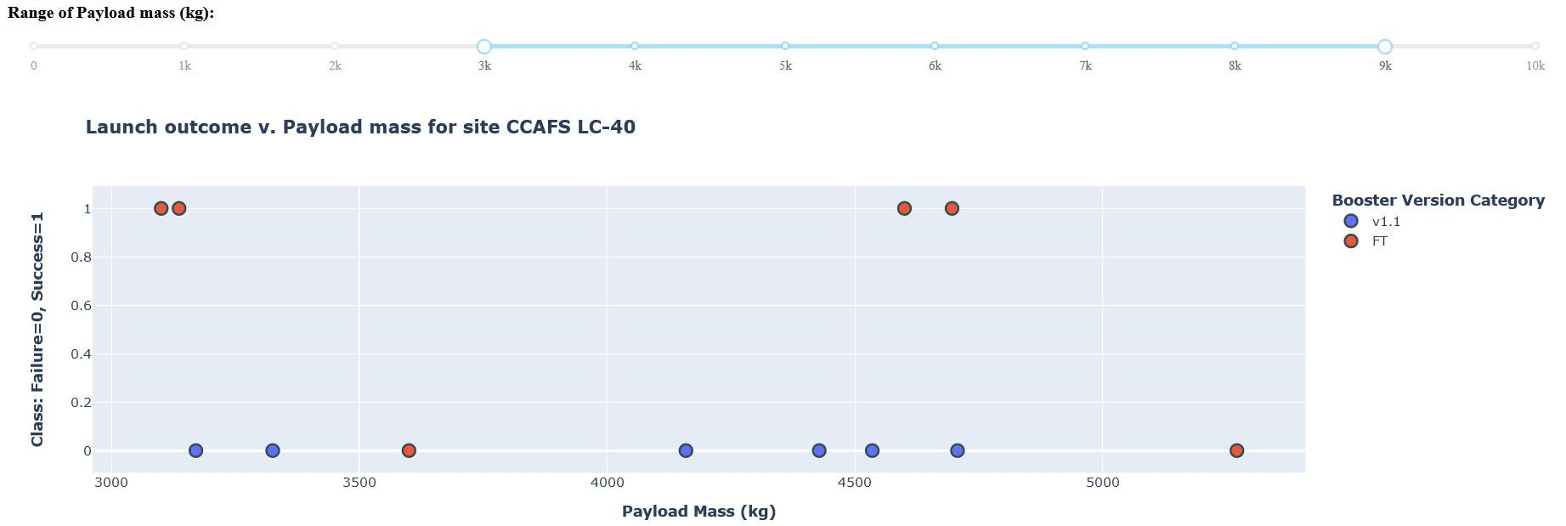

We built an interactive dashboard with Plotly including:

●

Dropdown menu for selecting launch sites

●

Pie charts displaying success rate.

●

Scatter chart displaying launch site, payload mass,

success/failure

●

Range slider for selecting range of payload mass (kg).

for analyzing SpaceX launch records features:

●

site with largest successful launches.

●

site with highest launch success rate

●

payload range(s) with highest launch success rate

●

payload range(s) with lowest launch success rate

●

F9 Booster version (v1.0, v1.1, FT, B4, B5, etc.) with

highest launch success rate.



Predictive Analysis (Classification)

Optimization of models hyper-parameters with

Scikit-learn GridSearchCV

Refined Optimization when possible (LR, SVM)

for achieving highest accuracy with training set.

**Note to the reviewer**

:

Data was shuffled in the split data process. For

making results a bit more interesting

**“**

**train_test_split( X, Y, test_size=0.2, random_state=3)”**

**Logistic Regression**

**Support Vector**

**Machine**

(

**SVM)**

**Decision Tree**

**Classifier**

**K Nearest Neighbors**

**Classifier**

**Model Training**

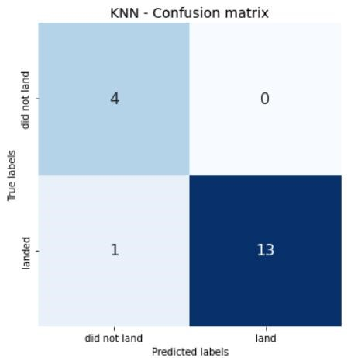

Split Data: Training, Testing Sets

Shuffling option !

Imported Falcon9 launching data

from .csv to Pandas dataframe

**Supervised Classification models**

Launcher landing Labels

●

Class 0: fail

●

Class 1: success

Data normalization

**Predictive analysis**

Accuracy

Confusion matrix

**Testing set**

Selection of best model



•

Exploratory data analysis results

•

Interactive analytics demo in screenshots

•

Predictive analysis results

Results

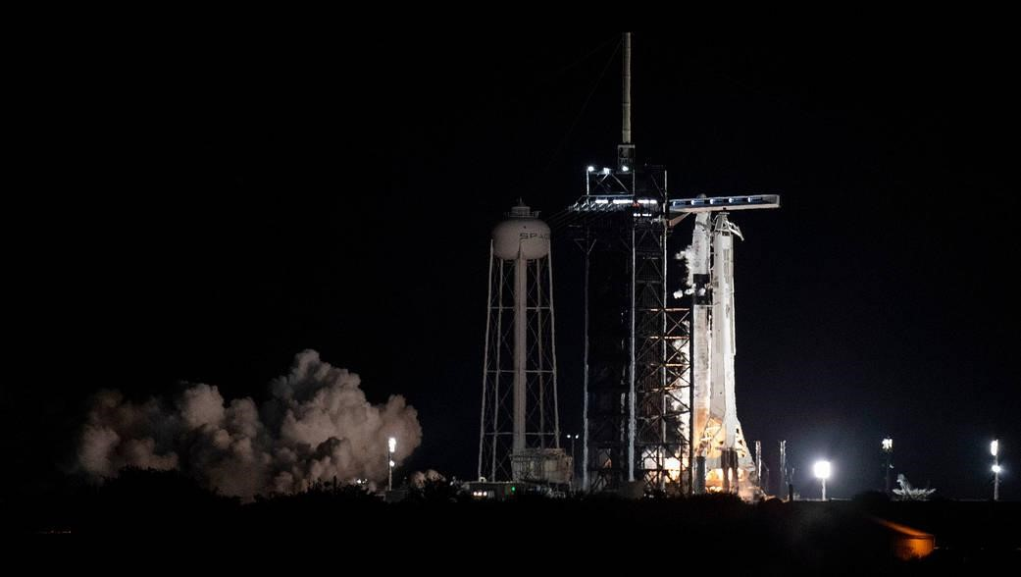

Section 2

**Insights drawn**

**from EDA**



Launch Site v. Flight Number

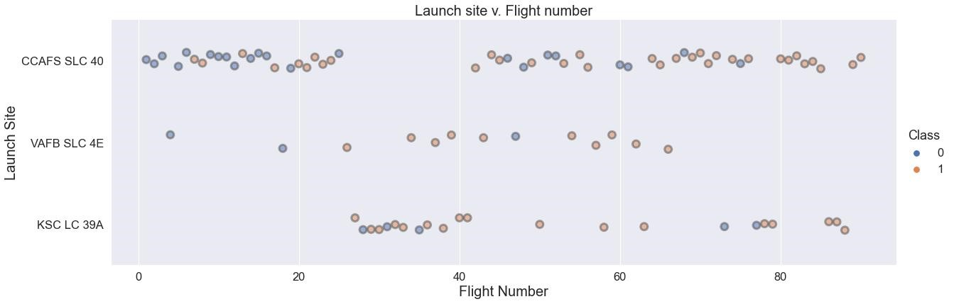

The chart displays valuable info about:

●

Chronology: flight numbers

●

Number of flights per launch site

●

Success/Failure per launch site

●

Cape Canaveral

CCAFS-SLC 40 is the most used launch site.

●

CCAFS-SLC 40 concentrates most of failures , particularly

**in the early stage of Falcon9 project**

.

●

Given CCAFS-SLC 40 southern location, most “risky” GTO and GEO launches may take place there.

●

Additional info needed: orbit, payload mass



Launch Site v. Payload

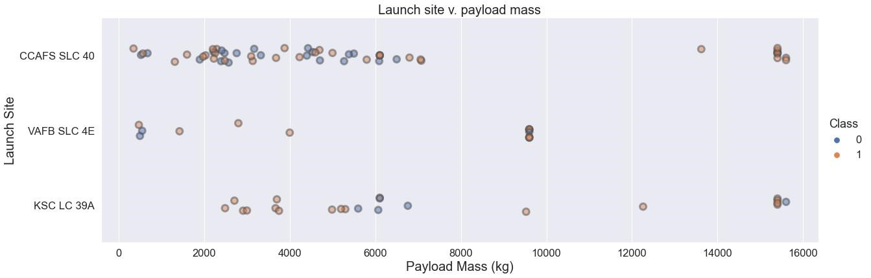

The chart brings additional info:

●

Payload mass per launch site

●

Success/Failure per payload mass

●

Given Falcon9 specifications, heavy payloads > 10000 kg are sent to low/medium orbits LEO/MEO only.

●

It looks like the percentage of failures is lower for heavy payload. Which would indicate that low orbits

are less risky to the success of the mission (recovery of booster).

●

Light payloads are not necessarily all sent to GTO/GEO.

●

More information is needed for extracting some correlation: success rate v. payload/orbit



Orbit Type v. Flight Number

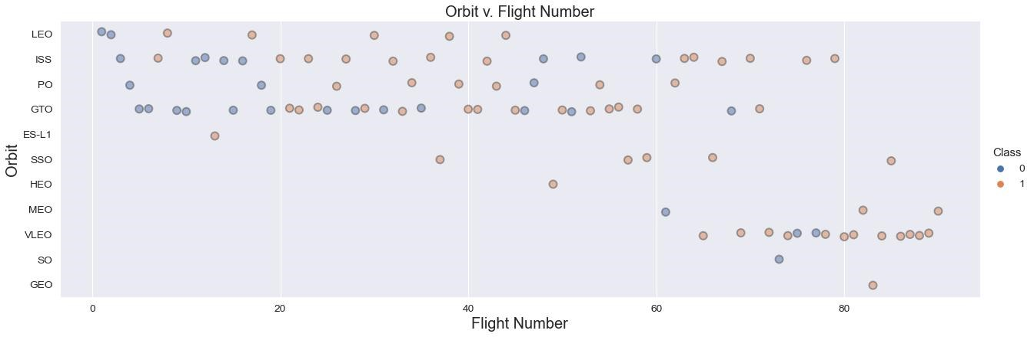

The chart brings additional info:

●

Number of flights per Orbit.

●

Success rate per orbit

●

The number of flights for: GEO, SO, HEO, ESL-1, MEO is not significant for concluding about success rate.

●

PO, SSO, ISS, VLEO are low orbits

●

GTO is a transfer orbit to GEO.

It looks like GTO are higher risk missions, low orbits are lower risk.

We confirm with the following histogram.



Success Rate vs. Orbit Type

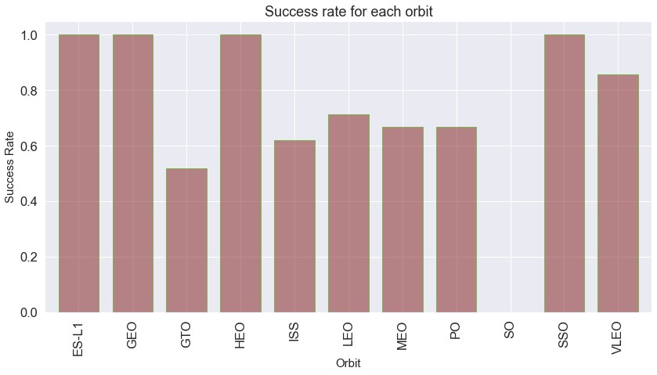

**Remarks:**

●

GTO is a transfer orbit to GEO. Low thrust engines of the payload

(

satellite) complete the orbiting phase.

●

We ignore results: GEO, SO, HEO, ESL-1, MEO. The number of flights

is not significant.

**GTO sees the lowest success rate as suggested in previous slide.**

**SSO**

(

polar low orbit

)

**the highest one.**

**Success rate may strongly depend on both:**

●

payload mass

●

orbit.

**meaning the amount of energy deployed at lift-off**

,

that may induce

***strong noise/vibrations that are known to damage satellites\****

.

Vibrations could damage some of the booster electronics, inertial

guidance systems... and cause booster recovery/landing failure.

We also need additional info about payload mass/orbit. Fortunately it is

available.

*

[https://adsabs.harvard.edu/full/1996ESASP.386..237](https://adsabs.harvard.edu/full/1996ESASP.386..237F)

[F](https://adsabs.harvard.edu/full/1996ESASP.386..237F)



Orbit Type v. Payload

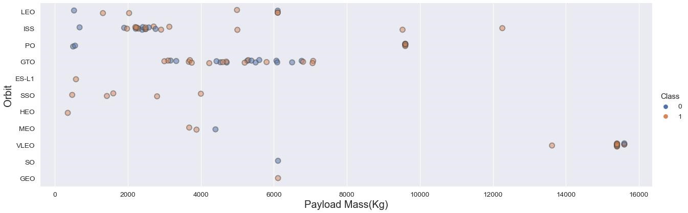

The chart brings final info about “Orbit v. Payload”. It describes the

distribution “success rate v. (payload, orbit)”

Main trends:

●

Maximum success rate with: low orbit except (ISS) and low payload mass

●

ISS: based on “

Orbit Type v. Flight Number”

5

/8 failures occurred in the early stage of Falcon 9 project. When Falcon

9

reliability was low.

●

Between 2000 and 7500 kg, success rate seems to be evenly distributed for GTO.

●

Independently of payload mass, GTO is a risky “orbit” affecting missions’ success rate. Falcon 9 reliability improves

over time, but there are still recent failed booster recovery after GTO launches.



Total number of successful and failure mission outcomes (from SQL queries).

Here success is defined based on properly launching/orbiting payload. Success rate is very high: ~99% like Ariane-5.

Nevertheless, Falcon9 maintains a competitive advantage in terms of cost per kg compared with classic launchers

like Ariane-5,

**only if the reusable booster is recovered.**

Therefore Falcon9 “success rate” in this report is defined after successful booster recovery (landing).

Total Number of Successful and Failure Mission Outcomes

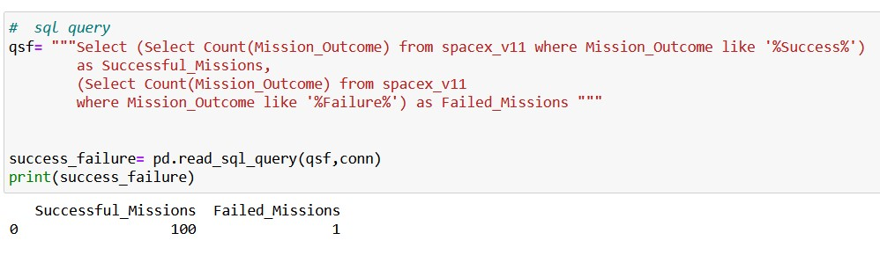

Launch Success Yearly Trend

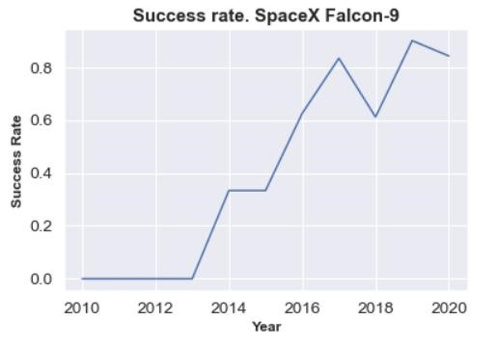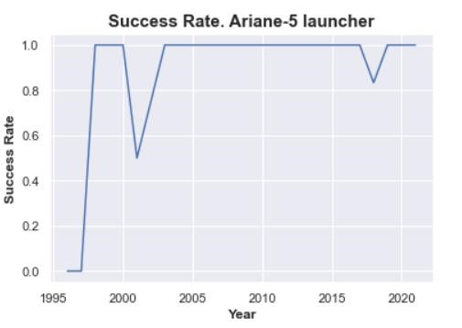

Falcon 9 reliability significantly improves over time .

Success rate,

**here defined after successful booster recovery for Falcon9,**

depends on:

●

Payload mass

●

Orbit

●

+

other factors we investigate next

●

Independently of payload mass, orbits,

**Ariane 5 has a close to 100% success rate**

for 82 flights since 2003.

●

Falcon9 average booster recovery success rate si 66%.

●

Success rate currently sufficient for SpaceX financial viability.

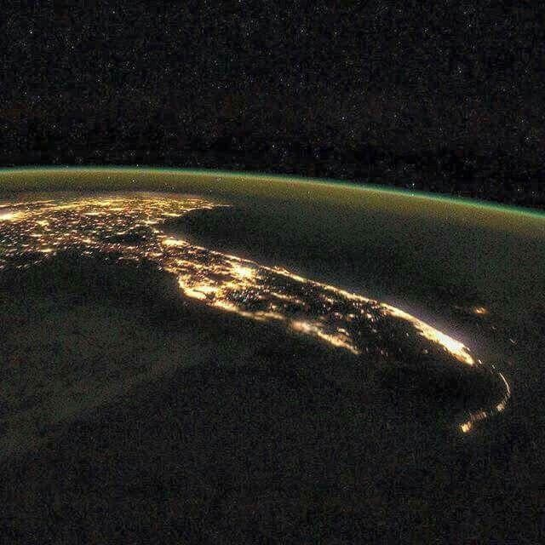

Section 3

**Launch Sites**

**Proximities Analysis**



Launch Site Names & Records

**Before starting launch sites analysis, we list the names of all launch sites and**

**some launch records (from SQL queries).**

**5**

**records where launch sites begin with `CCA`**

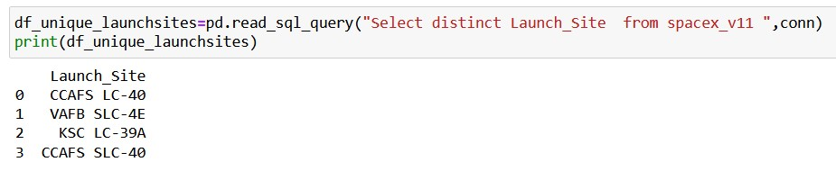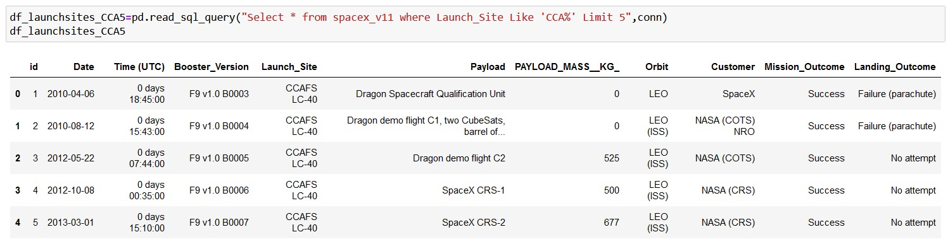

**There are 4 distinct launch sites**



Launch site v. Orbit type

We added that scattered chart, which has implications in the analysis of launch sites.

●

VAFB SLC 4E launch site in California, is used only for PO and SSO orbits,

**meaning**

**low altitude polar orbits.**

North or south? bound flights over the ocean.

●

**All GTO/GEO launches take place in Florida launch sites**

. As close as possible to the

equator where earth tangential velocity is maximum, acting like a slingshot at lift off,

from west to east over the ocean. (see gif).

**This helps with orbiting GEO satellites**

**with less energy.**

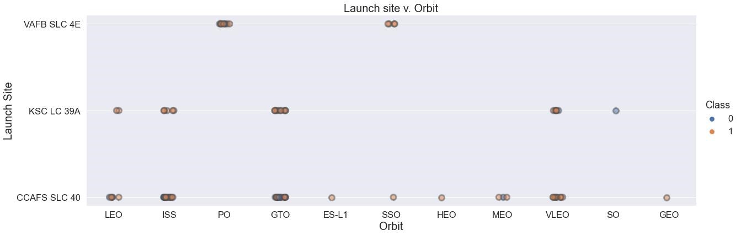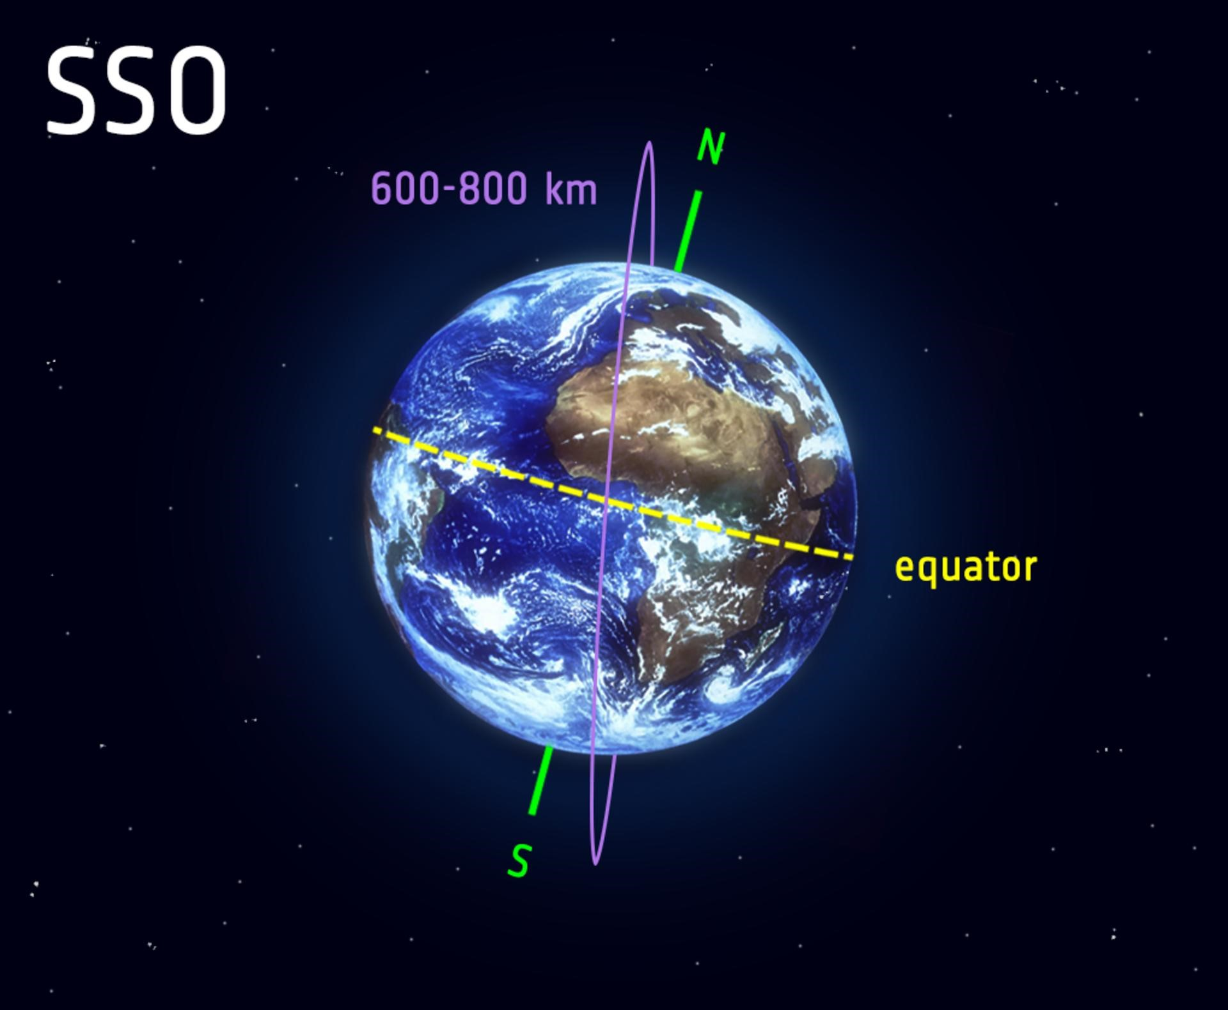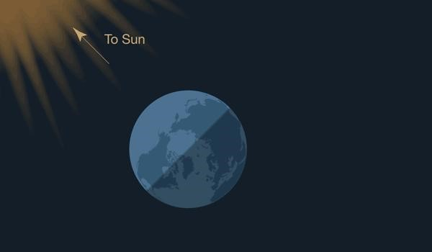

SpaceX: All launch sites

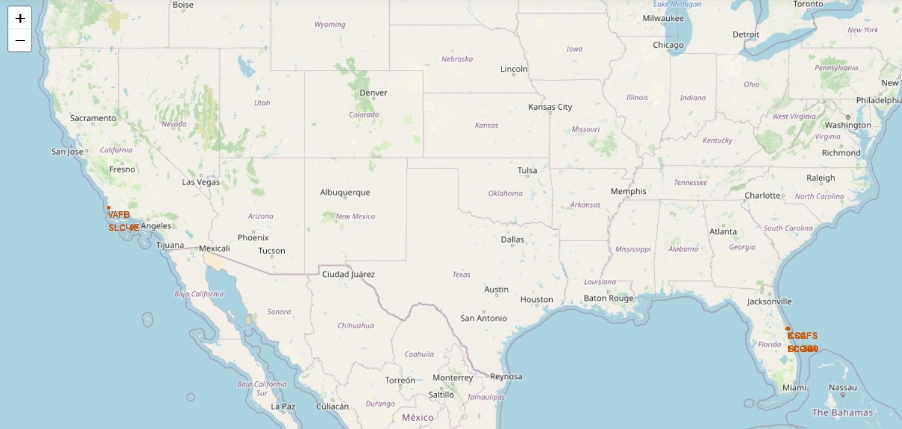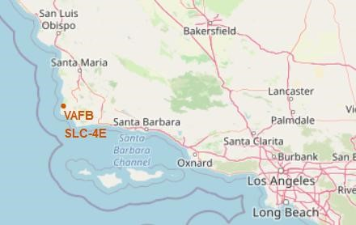

●

**VAFB SLC-4E: Vandenberg Space Launch Complex 4 (CA)**

●

**KSC-LC29A: Kennedy Space Center - Merritt Island (FL)**

●

**CCAFS-LC40: Cape Canaveral Launch Complex 40 (FL)**

●

**CCAF-SLC40: Cape Canaveral Space Launch Complex 40(FL)**

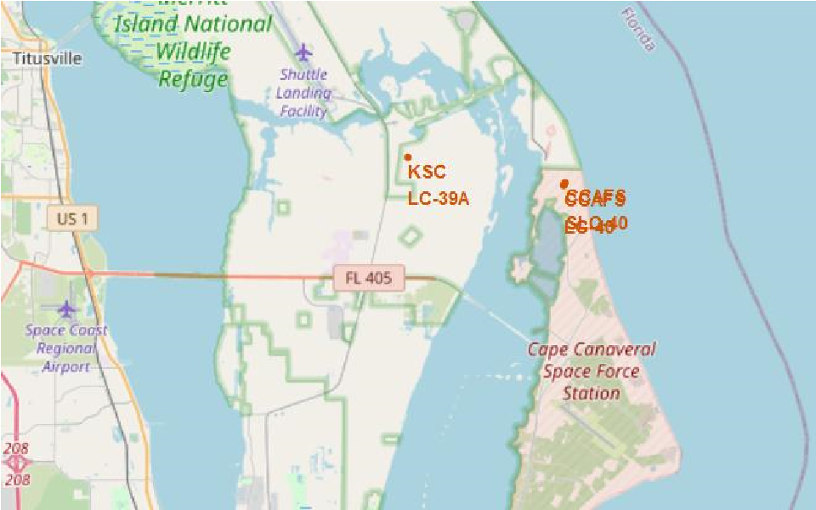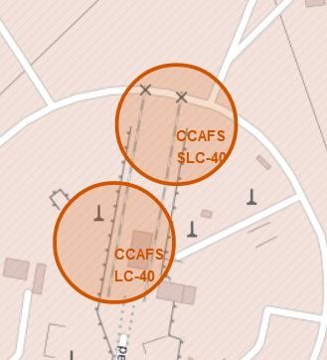

Falcon 9 Success/Failed launches for each site

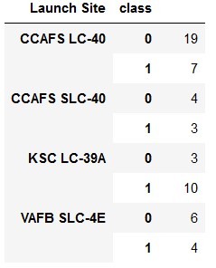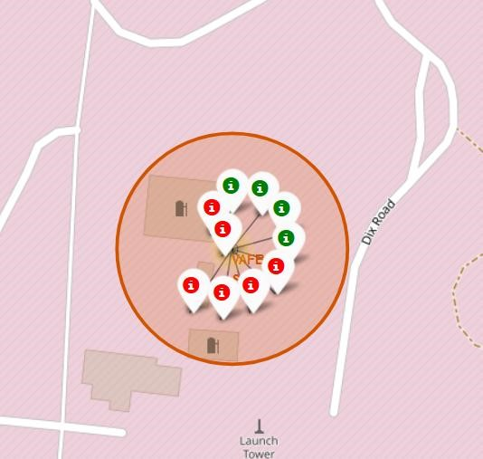

Vandenberg Space Launch Complex 4 (CA)

VAFB SLC-4E

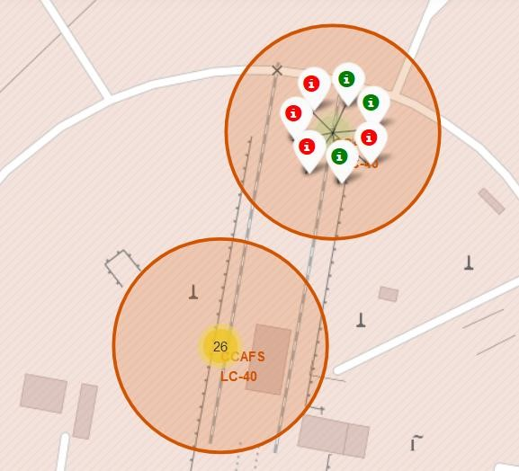

Cape Canaveral (FL)

CCAFS-SLC40

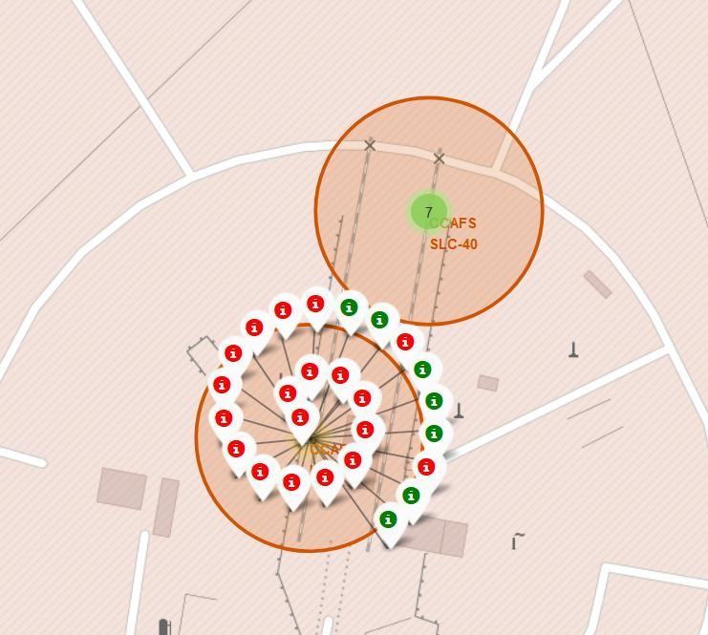

Cape Canaveral (FL)

CCAFS-LC40

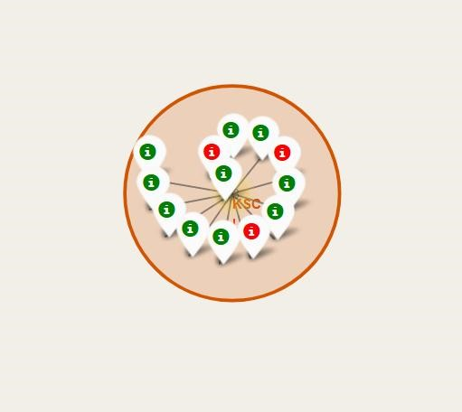

Kennedy Space Center (FL)

KSC LC 39A

**Table: Synthesis of launches outcomes**

Class 0= failure

Class 1= success



Distances between a launch site to its proximities

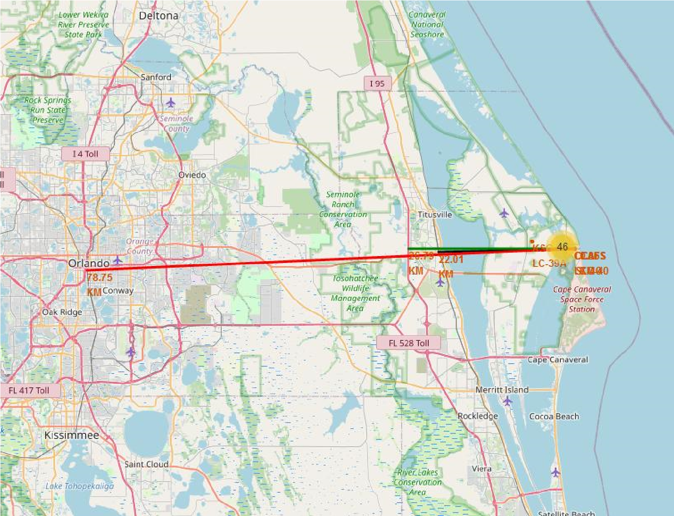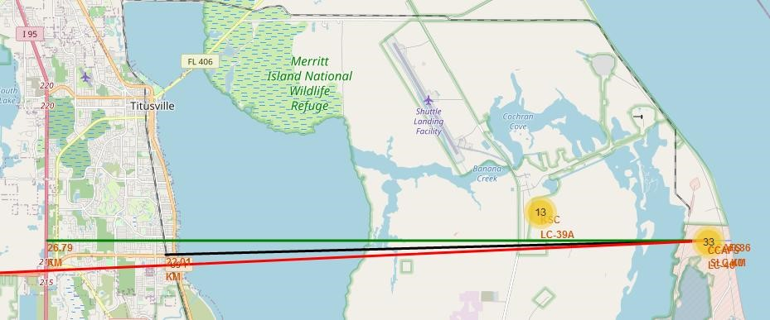

**Distance from CCAFS_SLC40 to:**

●

**Closest coast: ~900 m**

●

**Florida East Coast Railway: 22.0 km**

●

**Highway I 95: 26.8 km**

●

**Orlando: 78.75 km**

Launch sites are close to coasts. For safety issues if launcher is lost in the

early stage of the flight.

Rockets are launched:

●

From West to East over the ocean in Florida.

●

North or South bound over the ocean in California. (Polar orbits only)

Launch sites are relatively far from populated areas for protecting

population from serious incidents at lift off: explosion on the launch pad.



ESA Unique Launch site – Kourou, French Guiana.

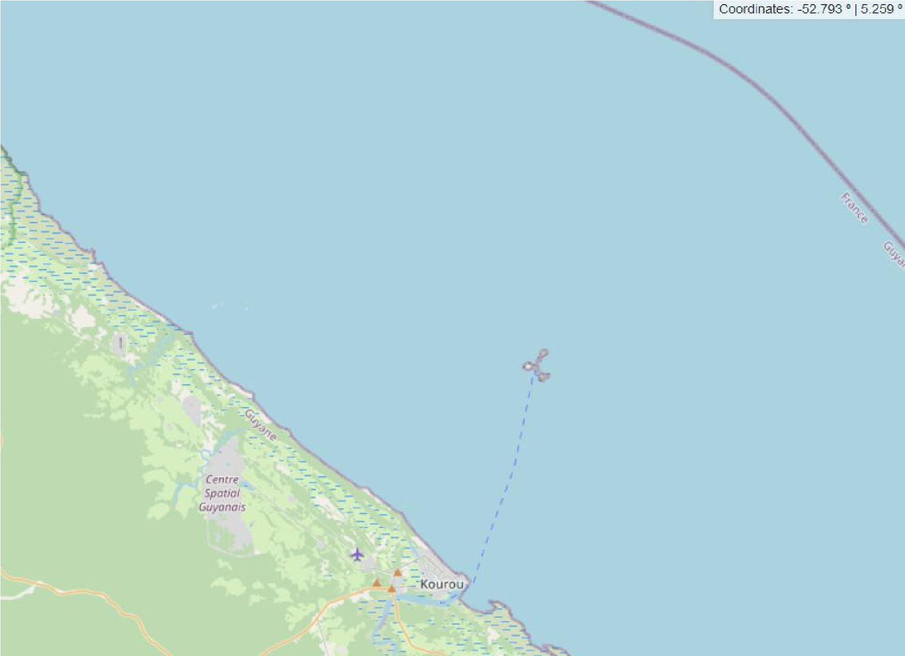

**Soyuz launch pad**

**Ariane launch pad**

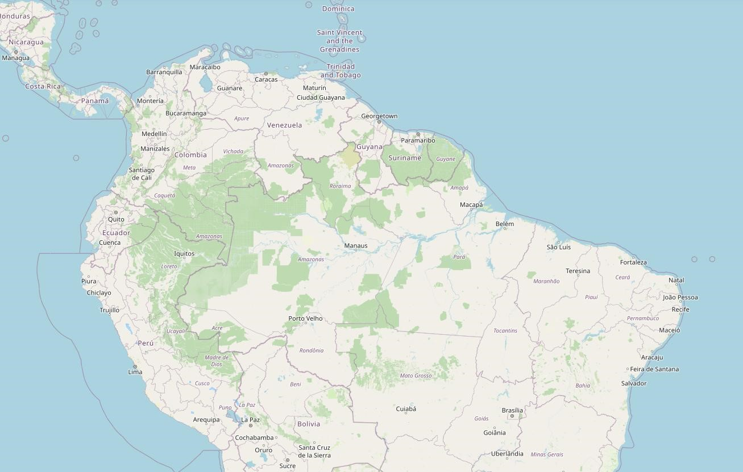

**European Space Agency (ESA)/ArianeEspace launch**

**sites in Kourou, French Guiana (France).**

Kourou launch sites: Ariane, Soyuz

●

are very close to the Equator: it’s a strong advantage

for GTO/GEO flights

●

are in a remote area far from any high density

inhabited area and high traffic infrastructures

●

Are close to the coast

Strong Advantage over SpaceX, in terms of safety and

GTO/GEO flights and energy required at lift-off.

SpaceX could compete and reduce energy at lift-off for

GTO-GEO flights by introducing a concept like “Sea

Launch”.

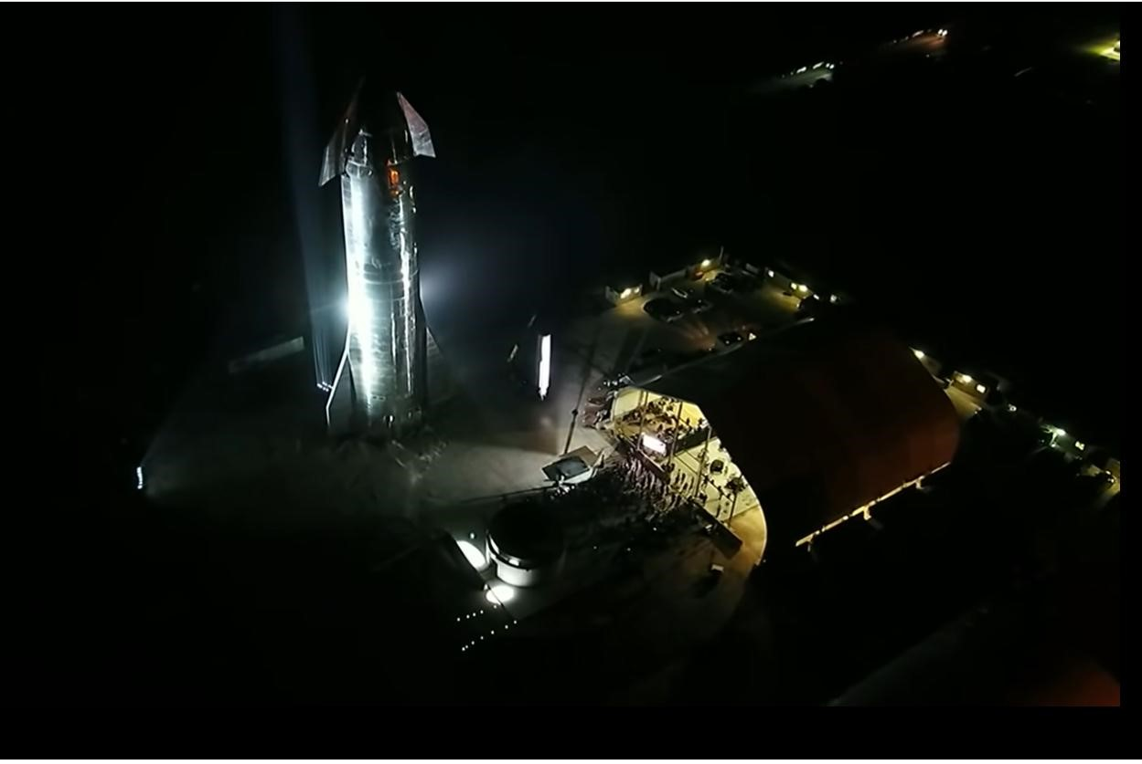

Section 3

**Build a Dashboard**

**With Plotly Dash**



SpaceX Falcon 9: Launch success count for all sites

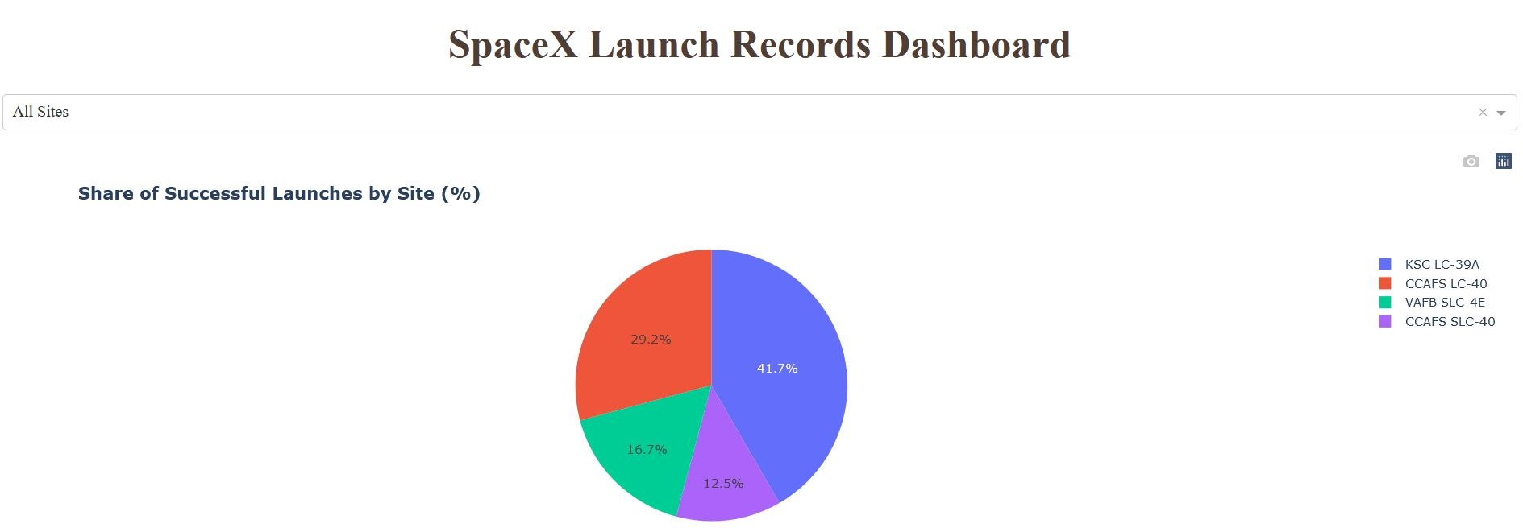

The dahsboard allows an interactive visualization and analysis of Falcon successful launches.

It completes scattered charts.

Here for all sites, we can identify the launch site with highest success rate.

Kennedy Space Center in Florida.



SpaceX Falcon9 Launch site with highest launch success ratio

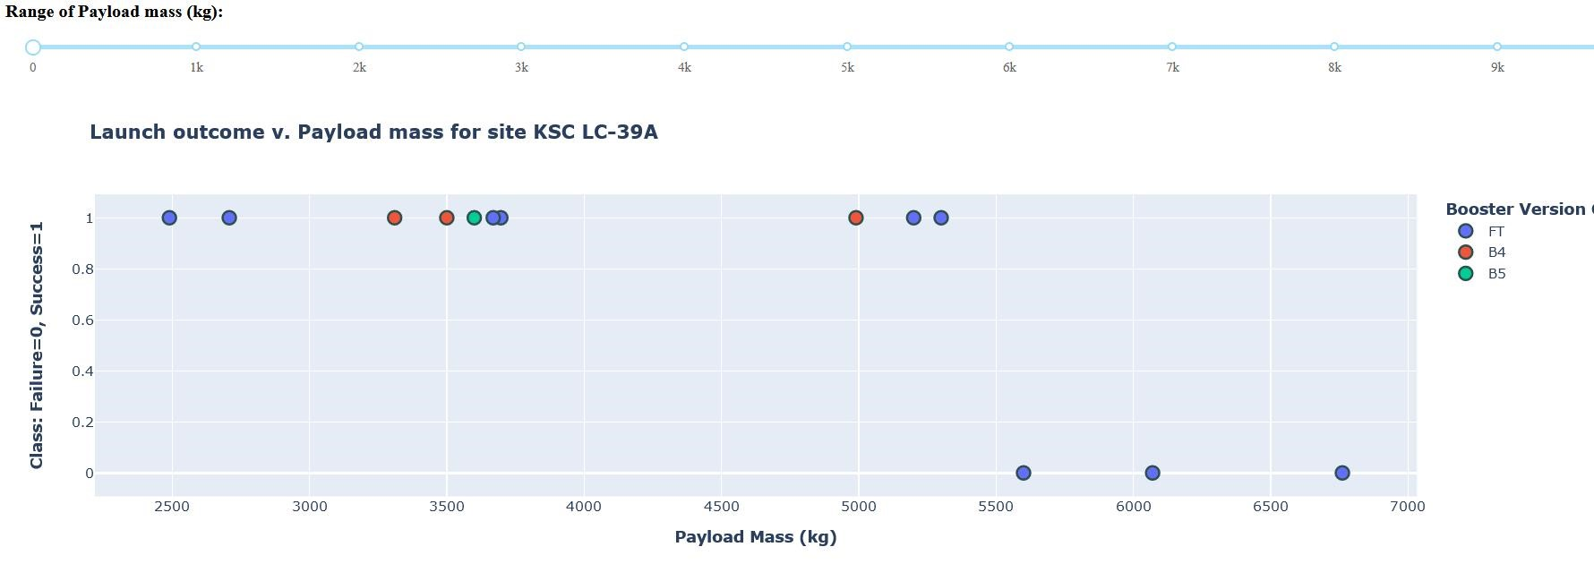

**KSC LC-39A**

Kennedy Space Center in Florida.

13

flights, 10 successful missions.

•

Heavy payload are “high risk”

•

Success does not seem to depend upon

boosters versions with low mass payload

<5500

kg.

•

B5 and FT are the most reused launchers.

Data is not sufficient, but may indicates that

they are as reliable as 1

st

time launchers.

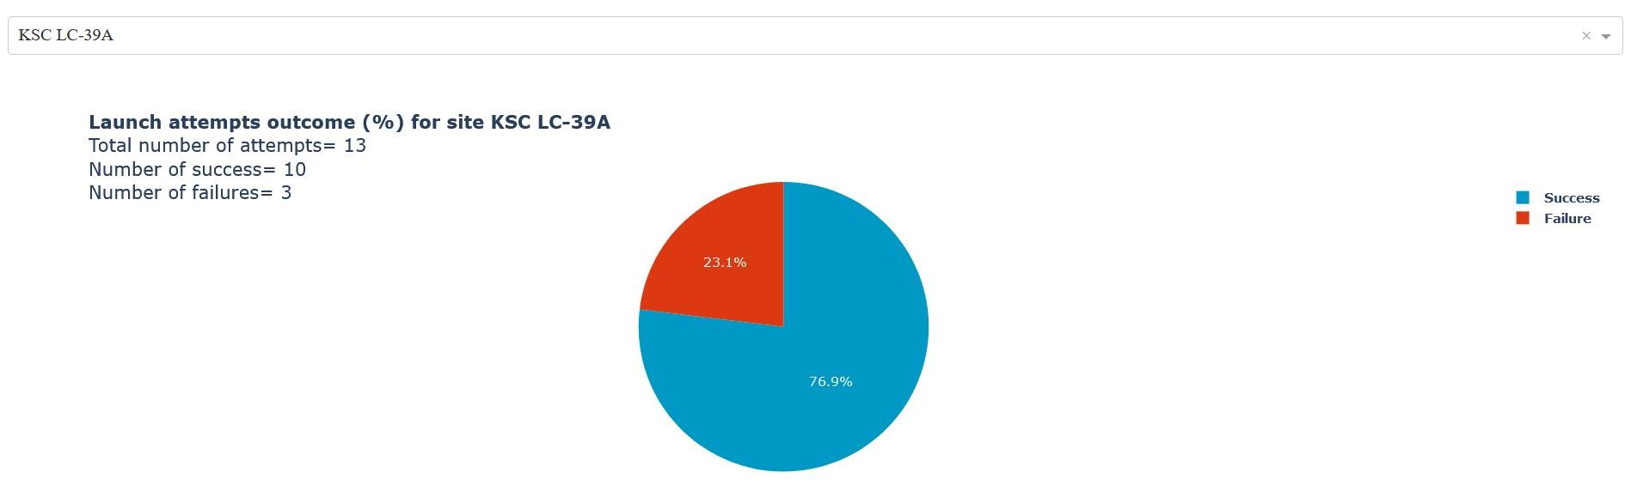

Launch outcome v. Payload mass (all sites)

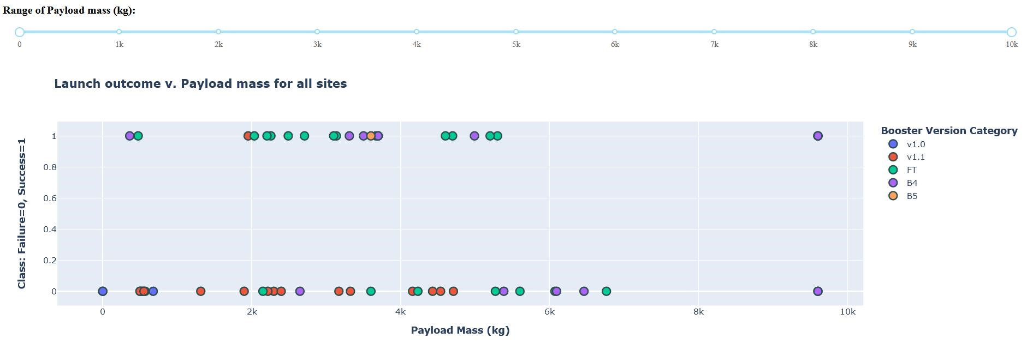

•

V1.0 and v1.1 are early launchers with low reliability.

Landing legs, were pioneered on the Falcon 9 v1.1 version, but that version never landed intact.

They were phased out in 2015.

●

FT: “Full Thrust” is the next generation and has the highest success rate for payload mass under 6 tons. Including with

“drone landing” (see details in next slide).

●

Many FT flights are done with reused launchers. And show good reliability.

●

Heavy payload are “high risk”.



List the names of Falcon 9 boosters which have successfully landed on drone ship and had

payload mass greater than 4000 but less than 6000 kg

Recent Full Thrust (FT) boosters exhibit the highest success rate on drone ship landing. Including

with GTO flights.

It bodes well if SpaceX introduces a concept like “Sea Launch” for GTO launches at sea, close to

the equator.

Successful Drone Ship Landing with Payload mass between 4000 and 6000 kg

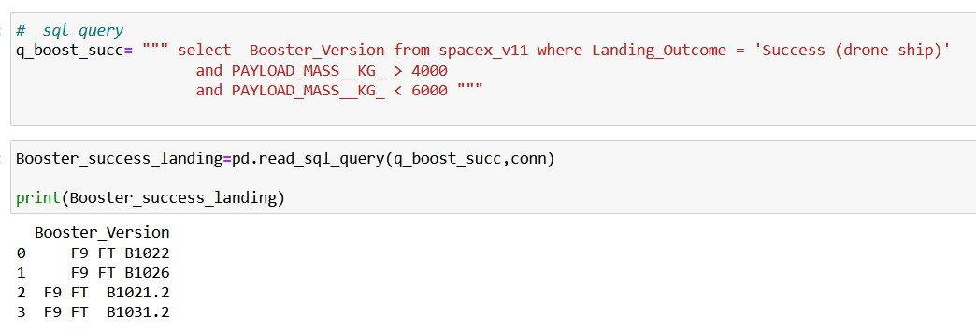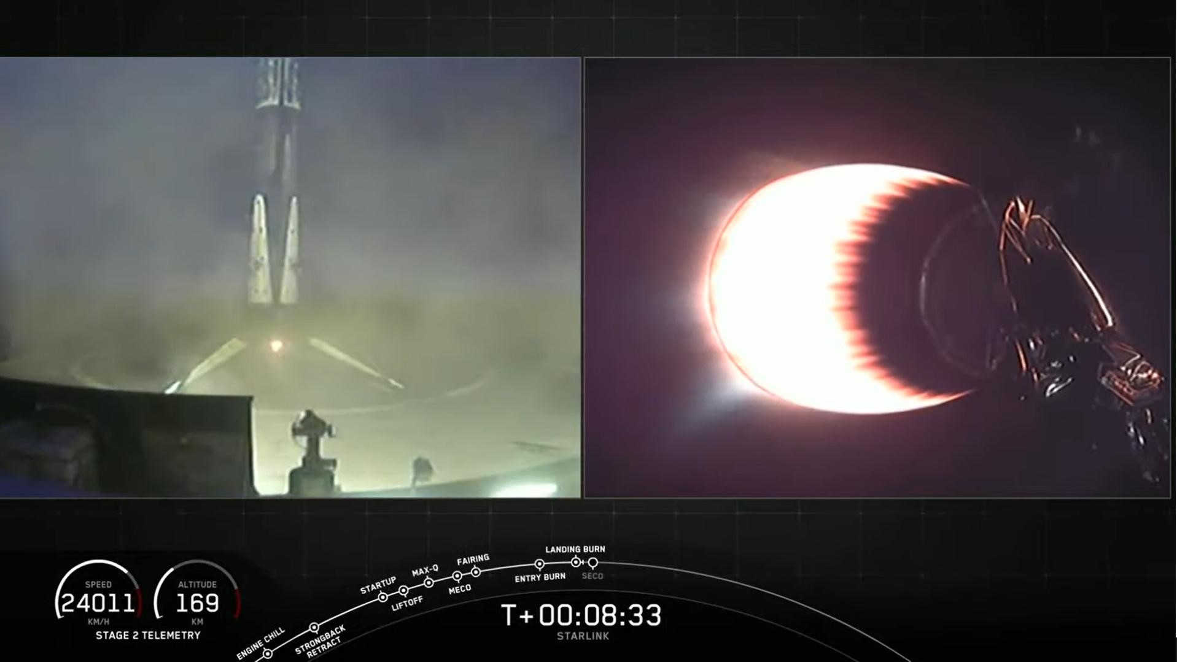

Section 5

**Predictive Analysis**

**(**

**Classification**

**)**



Classification Accuracy

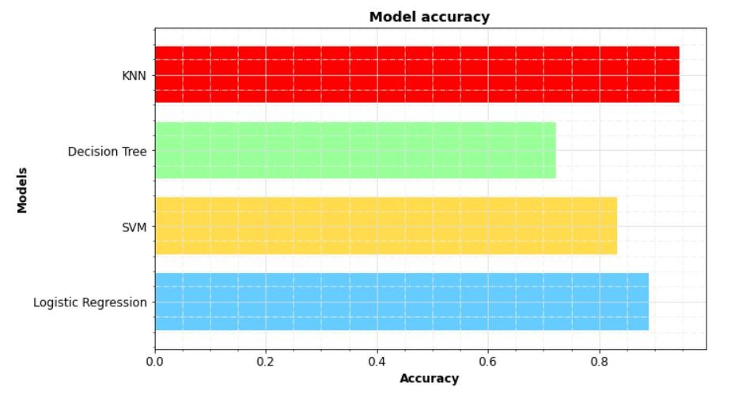

**Classification Accuracy with test set.**

Results with “train test split” random_state=3

●

Optimization of SVM and LR hyper-parameters was

refined for increasing accuracy with train set.

•

●

It did not necessarily improved accuracy with test set.

●

Test set is too small.

●

In our case, KNN exhibits the best accuracy: ~94%



•

k-nearest neighbors algorithm (k-NN) is the best “predictor”

•

The model perfectly predicts mission failure

•

1

false negative for successful booster landing (recovery)

Confusion Matrix

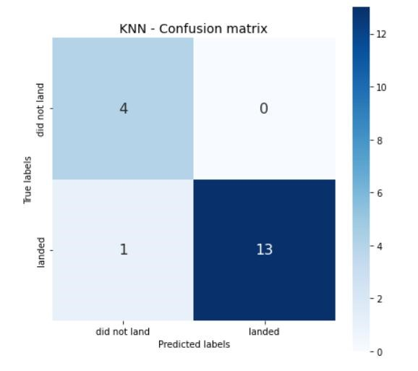

**Conclusions**



Conclusions

We defined success as a successful recovery process of Falcon9 booster.

From Falcon 9 and Wiki we imported data and developed tools for investigating factors driving successful booster recovery:

Payload, Orbit, Booster version, Launching sites…

Based on these features, we selected a supervised classification model capable of predicting launch outcome with a 94% accuracy.

Falcon9 booster recovery process is more risky than a classic launcher, but its success rate:

-

increases overtime

-

at 66%, it is sufficient for maintaining a competitive cost per kg compared with classic Ariane5 /Ariane 6.

SpaceX GEO/GTO flights are more risky.

Failure could be linked to energy deployed at lift-off, vibrations damaging of electronics, control systems of the booster.

ESA/ArianeEspace, Soyuz have an advantage in terms of launch site, on the equator: less energy is required for GTO/GEO flights.

SpaceX could improve GEO/GTO flights success with a concept like “Sea Launch” close to the equator.

Recent successes with FT boosters landing on “drone ship”, bodes well for such a solution.

Even with recent recovery failure for GTO/GEO, SpaceX will maintain a sufficient lead in terms of cost per kg. vs Ariane5 and the

new Ariane 6. Starship may well crush further the competition if similar success rate is achieved.



References and Jupyter Notebooks

[1]

[https://arstechnica.com/science/2021/03/european-leaders-say-an-immediate-response-needed-to-the-rise-of-spacex](https://arstechnica.com/science/2021/03/european-leaders-say-an-immediate-response-needed-to-the-rise-of-spacex/)

[/](https://arstechnica.com/science/2021/03/european-leaders-say-an-immediate-response-needed-to-the-rise-of-spacex/)

[2]

[https://www.arianespace.com/vehicle/ariane-5](https://www.arianespace.com/vehicle/ariane-5/)

[/](https://www.arianespace.com/vehicle/ariane-5/)

[3]

[https://www.arianespace.com/wp-content/uploads/2020/06/Arianespace_Brochure_Ariane5_Sept2019.pd](https://www.arianespace.com/wp-content/uploads/2020/06/Arianespace_Brochure_Ariane5_Sept2019.pdf)

[f](https://www.arianespace.com/wp-content/uploads/2020/06/Arianespace_Brochure_Ariane5_Sept2019.pdf)

[4]

[https://www.arianespace.com/ariane-6](https://www.arianespace.com/ariane-6/)

[/](https://www.arianespace.com/ariane-6/)

[5]

[https://www.arianespace.com/wp-content/uploads/2020/06/Arianespace_Brochure_Ariane6_Sept2019.pd](https://www.arianespace.com/wp-content/uploads/2020/06/Arianespace_Brochure_Ariane6_Sept2019.pdf)

[f](https://www.arianespace.com/wp-content/uploads/2020/06/Arianespace_Brochure_Ariane6_Sept2019.pdf)

[6]

[https://www.inverse.com/innovation/ariane-6-vs-space](https://www.inverse.com/innovation/ariane-6-vs-spacex)

[x](https://www.inverse.com/innovation/ariane-6-vs-spacex)

[7]

[https://adsabs.harvard.edu/full/1996ESASP.386..237](https://adsabs.harvard.edu/full/1996ESASP.386..237F)

[F](https://adsabs.harvard.edu/full/1996ESASP.386..237F)



Include any relevant assets like Python code snippets, SQL queries,

charts, Notebook outputs, or data sets that you may have created during

this project

Appendix: SQL queries



**Calculate the total payload carried by boosters from NASA (2 methods)**

Total Payload Mass

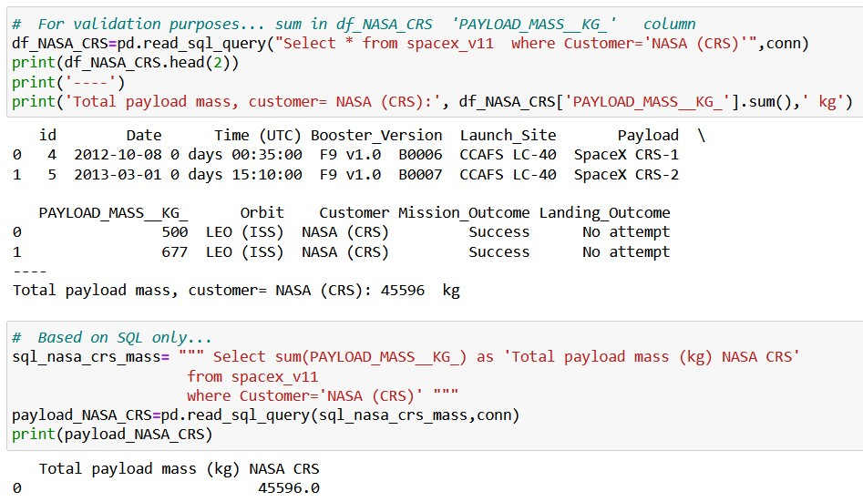

Calculate the average payload mass carried by booster version F9 v1.1

Average Payload Mass by F9 v1.1

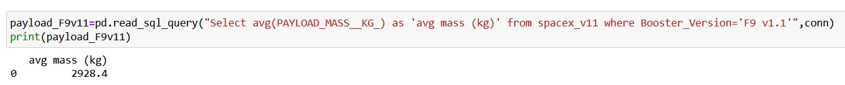

Find the dates of the first successful landing outcome on ground pad

First Successful Ground Landing Date

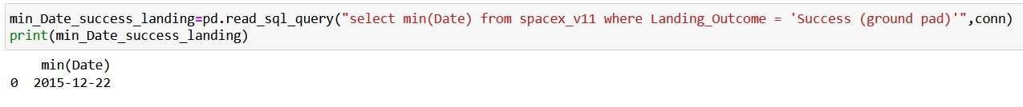

List the names of the boosters which have carried the maximum payload mass

Boosters Carried Maximum Payload

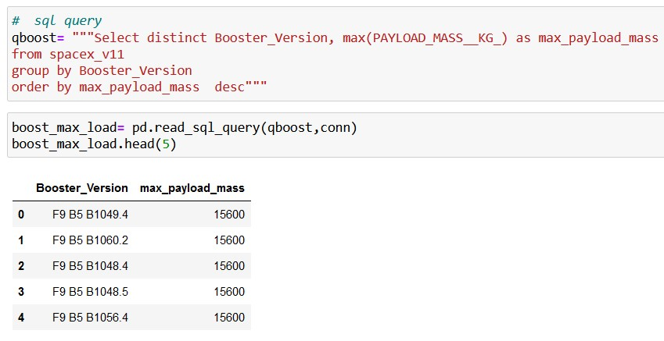

List the failed

landing_outcomes in drone ship, their booster versions, and

launch site names for in year 2015

2015

Launch Records

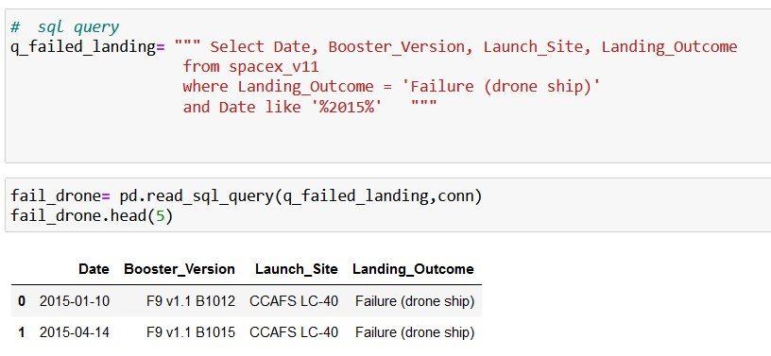

Rank the count of landing outcomes (such as Failure

(

drone ship) or Success (ground pad)) between the

date 2010-06-04 and 2017-03-20, in descending order

Rank Landing Outcomes Between 2010-06-04 and 2017-03-20

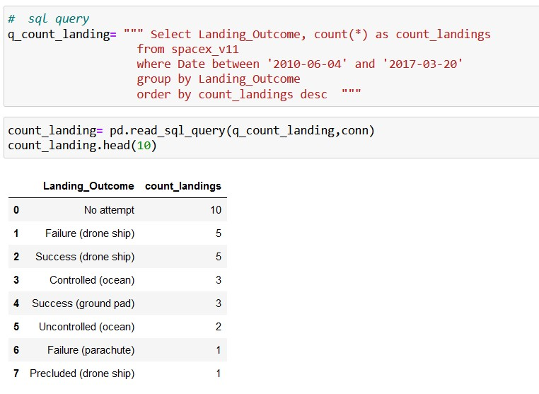

PO, SSO, GTO, GEO. From ESA website.

Glossary

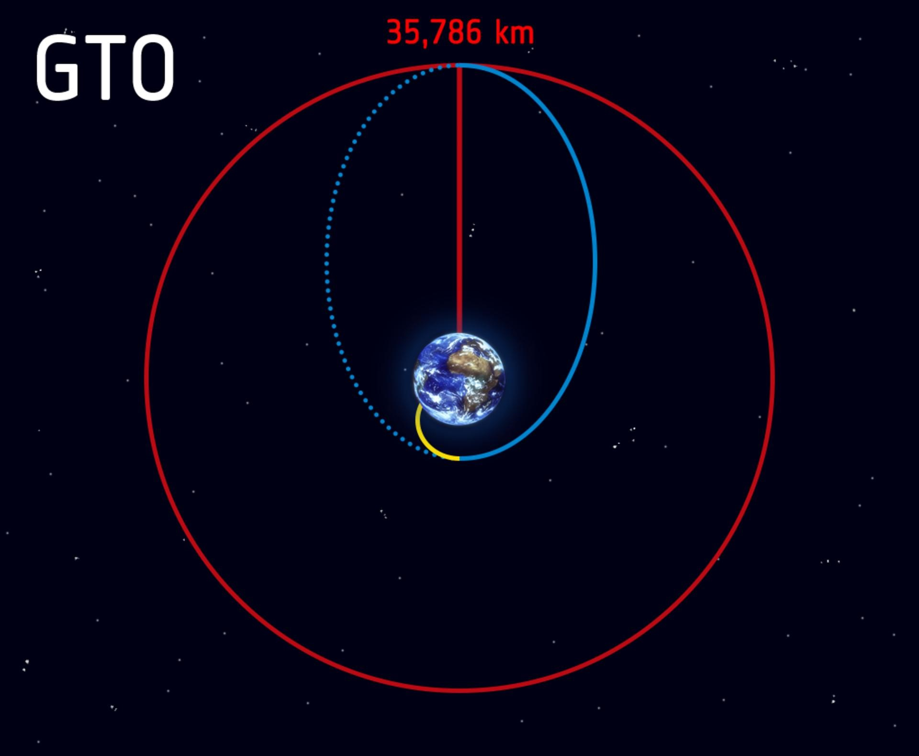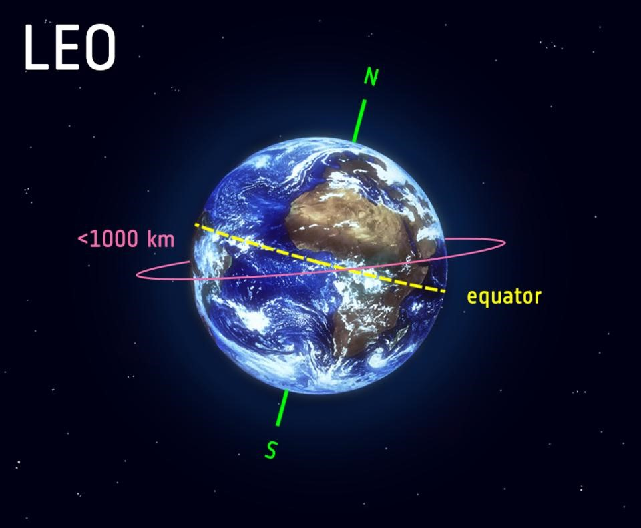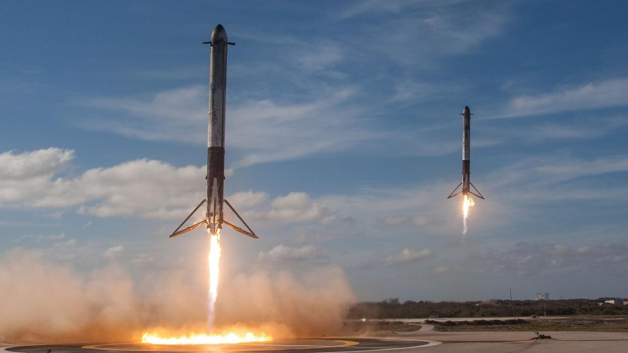

**Thank you !**